Food

Food – Fun – Family Ozark City Schools

Child Nutrition Department

March

**Hobo Dinner**

Easy to do and Prep Ahead

In a foil, place the following items your kids like:

Hamburger meat

Potato Slice

Onion Slice

Carrots

Season everything

Wrap in the foil, place in the slow cooker on low all day.

Fun

Take a walk around your neighborhood or your street. Learn some of the plants and notice which flowers are getting ready to bloom.

Family

It’s **Spring Time**! Try planting something small. If your family enjoys tomatoes, try some cherry tomatoes! They are easy to grow and usually produce a lot of good tomatoes. If tomatoes are not your pick – try cucumbers or maybe a pretty pot of flowers. Gardening is a great hobby to learn and a great way to get outside together!!!

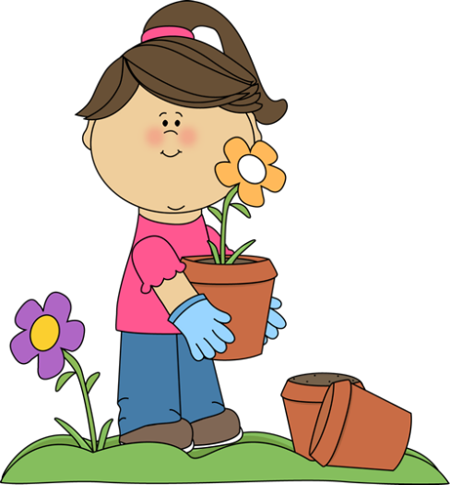

Happy Spring!

***SPRING BREAK IS MARCH 24 – 28, 2025!!!***